Main XML:

<?xml version="1.0" encoding="utf-8"?>  
<androidx.constraintlayout.widget.ConstraintLayout xmlns:android="http://schemas.android.com/apk/res/android"  
 xmlns:app="http://schemas.android.com/apk/res-auto"  
 xmlns:tools="http://schemas.android.com/tools"  
 android:layout_width="match_parent"  
 android:layout_height="match_parent"  
 tools:context=".MainActivity">  
  
 <TextView  
  
 android:layout_width="wrap_content"  
 android:layout_height="wrap_content"  
 android:text="CAR SHOWROOM"  
 android:textAlignment="center"  
 android:textColor="#070707"  
 android:textSize="24sp"  
 app:layout_constraintBottom_toBottomOf="parent"  
 app:layout_constraintHorizontal_bias="0.5"  
 app:layout_constraintLeft_toLeftOf="parent"  
 app:layout_constraintRight_toRightOf="parent"  
 app:layout_constraintTop_toTopOf="parent"  
 app:layout_constraintVertical_bias="0.1"  
 android:gravity="center_horizontal" />  
  
 <ImageView  
 android:layout_width="90dp"  
 android:layout_height="90dp"  
 android:id="@+id/image1"  
 android:src="@drawable/chiron"  
 tools:ignore="MissingConstraints"  
 app:layout_constraintBottom_toBottomOf="parent"  
 app:layout_constraintHorizontal_bias="0.1"  
 app:layout_constraintLeft_toLeftOf="parent"  
 app:layout_constraintRight_toRightOf="parent"  
 app:layout_constraintTop_toTopOf="parent"  
 app:layout_constraintVertical_bias="0.3" />  
  
 <ImageView  
 android:layout_width="90dp"  
 android:layout_height="90dp"  
 android:id="@+id/image2"  
 android:src="@drawable/tri"  
 tools:ignore="MissingConstraints"  
 app:layout_constraintBottom_toBottomOf="parent"  
 app:layout_constraintHorizontal_bias="0.1"  
 app:layout_constraintLeft_toLeftOf="parent"  
 app:layout_constraintRight_toRightOf="parent"  
 app:layout_constraintTop_toTopOf="parent"  
 app:layout_constraintVertical_bias="0.5" />  
  
 <ImageView  
 android:layout_width="90dp"  
 android:layout_height="90dp"  
 android:id="@+id/image4"  
 android:src="@drawable/gtr"  
 tools:ignore="MissingConstraints"  
 app:layout_constraintBottom_toBottomOf="parent"  
 app:layout_constraintHorizontal_bias="0.7"  
 app:layout_constraintLeft_toLeftOf="parent"  
 app:layout_constraintRight_toRightOf="parent"  
 app:layout_constraintTop_toTopOf="parent"  
 app:layout_constraintVertical_bias="0.3" />  
  
 <ImageView  
 android:id="@+id/image3"  
 android:layout_width="86dp"  
 android:layout_height="87dp"  
 android:src="@drawable/mac"  
 app:layout_constraintBottom_toBottomOf="parent"  
 app:layout_constraintHorizontal_bias="0.7"  
 app:layout_constraintLeft_toLeftOf="parent"  
 app:layout_constraintRight_toRightOf="parent"  
 app:layout_constraintTop_toTopOf="parent"  
 app:layout_constraintVertical_bias="0.5"  
 tools:ignore="MissingConstraints" />  
  
  
  
  
  
  
</androidx.constraintlayout.widget.ConstraintLayout>

Main Activity Java

package com.example.car_showroom;  
  
import androidx.appcompat.app.AppCompatActivity;  
  
import android.content.Intent;  
import android.os.Bundle;  
import android.view.View;  
import android.widget.GridView;  
import android.widget.ImageView;  
  
public class MainActivity extends AppCompatActivity {  
ImageView img1,img2,img3,img4;  
  
 @Override  
 protected void onCreate(Bundle savedInstanceState) {  
 super.onCreate(savedInstanceState);  
 setContentView(R.layout.*activity_main*);  
 img1=findViewById(R.id.*image1*);  
 img2=findViewById(R.id.*image2*);  
 img3=findViewById(R.id.*image3*);  
 img4=findViewById(R.id.*image4*);  
  
 img1.setOnClickListener(new View.OnClickListener() {  
 @Override  
 public void onClick(View v) {  
 Intent intent=new Intent(getApplicationContext(),MainActivity2.class);  
 intent.putExtra("Chiron","Bugatti Chiron\n Blue \n Ex-Showroom:10cr \n On-Road:11.1cr");  
 startActivity(intent);  
 }  
 });  
  
 img2.setOnClickListener(new View.OnClickListener() {  
 @Override  
 public void onClick(View v) {  
 Intent intent=new Intent(getApplicationContext(),MainActivity2.class);  
 intent.putExtra("Mac","Mac 720s\n red \n Ex-Showroom:4cr \n On-Road:4.5cr");  
 startActivity(intent);  
 }  
 });  
 img3.setOnClickListener(new View.OnClickListener() {  
 @Override  
 public void onClick(View v) {  
 Intent intent=new Intent(getApplicationContext(),MainActivity2.class);  
 intent.putExtra("Tri","Ferrai Tributo\n red \n Ex-Showroom:3cr \n On-Road:3.5cr");  
 startActivity(intent);  
 }  
 });  
  
 img2.setOnClickListener(new View.OnClickListener() {  
 @Override  
 public void onClick(View v) {  
 Intent intent=new Intent(getApplicationContext(),MainActivity2.class);  
 intent.putExtra("Gtr","GTR\n silver \n Ex-Showroom:1cr \n On-Road:1.5cr");  
 startActivity(intent);  
 }  
 });  
  
  
  
  
 }  
}

Activity 2 XML:

<?xml version="1.0" encoding="utf-8"?>  
<androidx.constraintlayout.widget.ConstraintLayout xmlns:android="http://schemas.android.com/apk/res/android"  
 xmlns:app="http://schemas.android.com/apk/res-auto"  
 xmlns:tools="http://schemas.android.com/tools"  
 android:layout_width="match_parent"  
 android:layout_height="match_parent"  
 tools:context=".MainActivity2">  
  
 <TextView  
 android:layout_width="wrap_content"  
 android:layout_height="wrap_content"  
  
 android:text="DETAILS"  
 android:textAlignment="center"  
 android:textSize="24sp"  
 app:layout_constraintBottom_toBottomOf="parent"  
 app:layout_constraintHorizontal_bias="0.5"  
 app:layout_constraintLeft_toLeftOf="parent"  
 app:layout_constraintRight_toRightOf="parent"  
 app:layout_constraintTop_toTopOf="parent"  
 app:layout_constraintVertical_bias="0.1"  
 android:gravity="center_horizontal" />  
  
 <TextView  
 android:id="@+id/textView5"  
 android:layout_width="175dp"  
 android:layout_height="299dp"  
 android:paddingTop="50dp"  
 android:textAlignment="center"  
 android:textColor="#FFFFFF"  
 android:textSize="18sp"  
 app:layout_constraintBottom_toBottomOf="parent"  
 app:layout_constraintHorizontal_bias="0.5"  
 app:layout_constraintLeft_toLeftOf="parent"  
 app:layout_constraintRight_toRightOf="parent"  
 app:layout_constraintTop_toTopOf="parent"  
 app:layout_constraintVertical_bias="0.4"  
 android:gravity="center_horizontal" />  
  
</androidx.constraintlayout.widget.ConstraintLayout>

Activity 2 JAVA:

package com.example.car_showroom;  
  
import androidx.appcompat.app.AppCompatActivity;  
  
import android.content.Intent;  
import android.os.Bundle;  
import android.widget.TextView;  
  
public class MainActivity2 extends AppCompatActivity {  
  
 @Override  
 protected void onCreate(Bundle savedInstanceState) {  
 super.onCreate(savedInstanceState);  
 setContentView(R.layout.*activity_main2*);  
 Intent intent=getIntent();  
 String txt=intent.getStringExtra("Chiron");  
 TextView textView=(TextView)findViewById(R.id.*textView5*);  
 textView.setText(txt);  
  
 Intent intent1=getIntent();  
 String txt2=intent.getStringExtra("Mac");  
 TextView textView2=(TextView)findViewById(R.id.*textView5*);  
 textView2.setText(txt2);  
  
 Intent intent2=getIntent();  
 String txt3=intent.getStringExtra("tri");  
 TextView textView3=(TextView)findViewById(R.id.*textView5*);  
 textView3.setText(txt3);  
 Intent intent3=getIntent();  
 String txt4=intent.getStringExtra("gtr");  
 TextView textView4=(TextView)findViewById(R.id.*textView5*);  
 textView4.setText(txt4);  
 }  
}

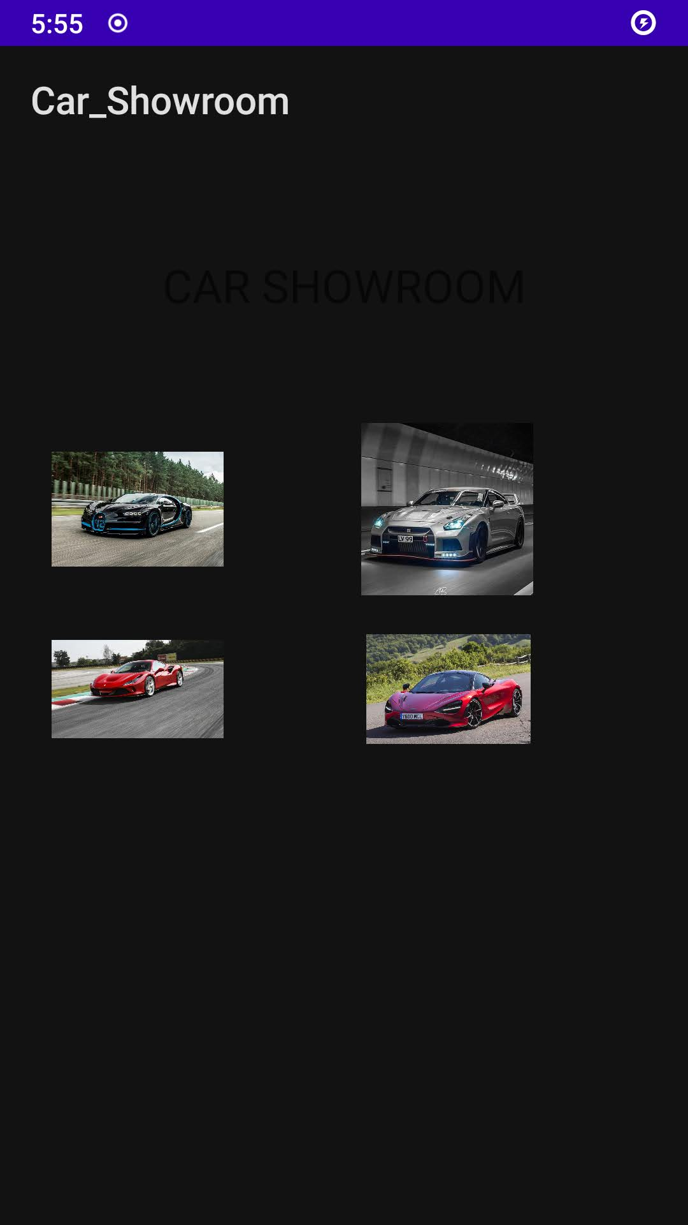

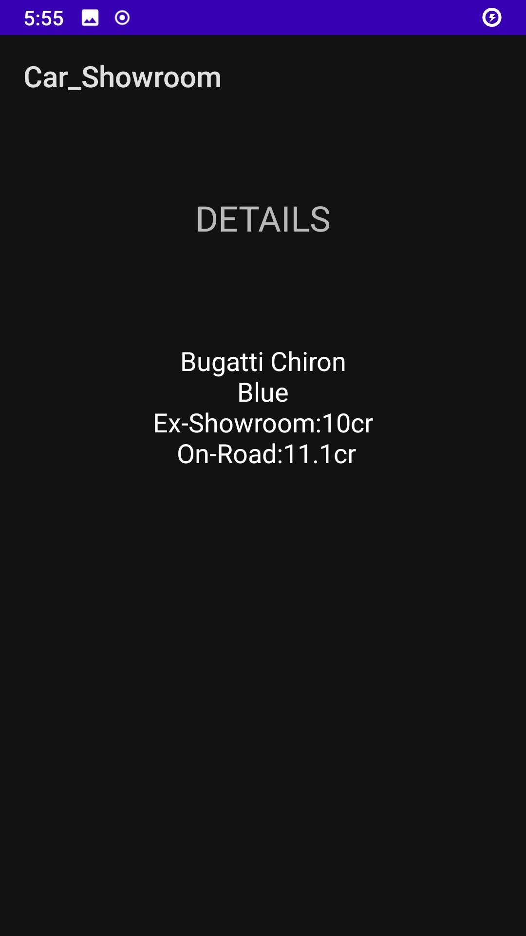

JAVA Write Up:

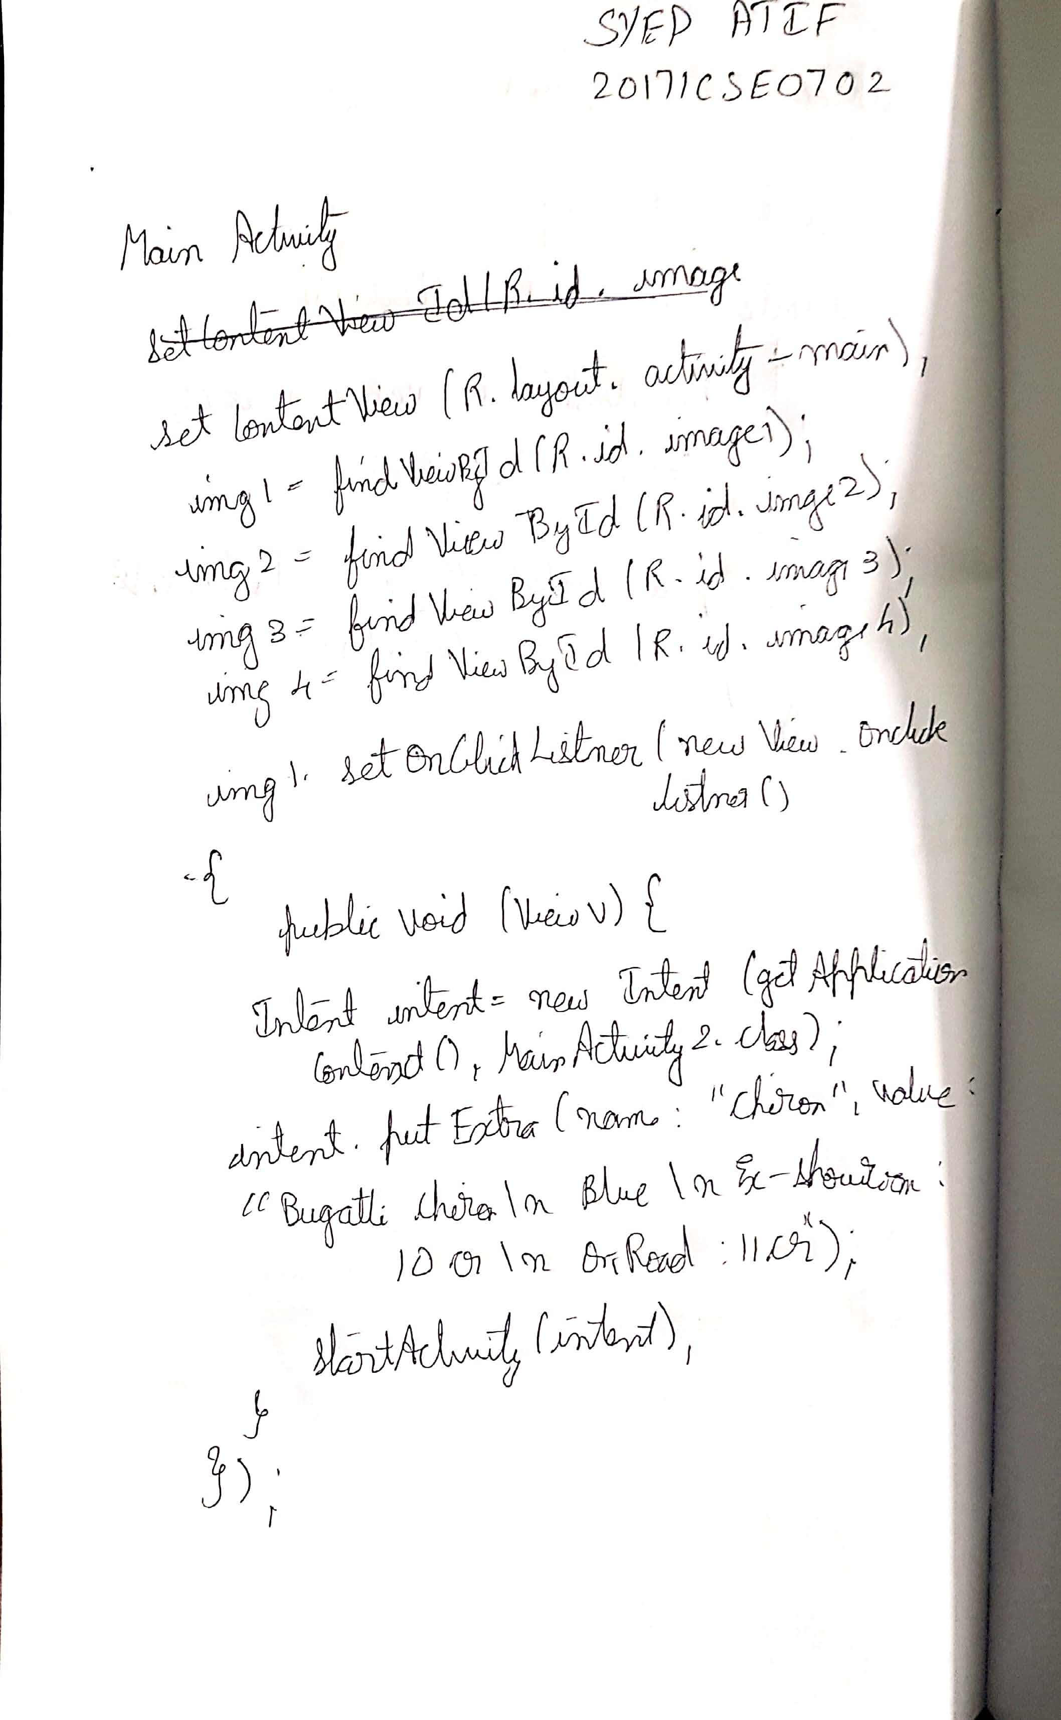

Main Activity 1:

package com.example.car_showroom;

import androidx.appcompat.app.AppCompatActivity;

import android.content.Intent;

import android.os.Bundle;

import android.view.View;

import android.widget.GridView;

import android.widget.ImageView;

public class MainActivity extends AppCompatActivity {

ImageView img1,img2,img3,img4;

@Override

protected void onCreate(Bundle savedInstanceState) {

super.onCreate(savedInstanceState);

setContentView(R.layout.activity_main);

img1=findViewById(R.id.image1);

img2=findViewById(R.id.image2);

img3=findViewById(R.id.image3);

img4=findViewById(R.id.image4);

img1.setOnClickListener(new View.OnClickListener() {

@Override

public void onClick(View v) {

Intent intent=new Intent(getApplicationContext(),MainActivity2.class);

intent.putExtra("Chiron","Bugatti Chiron\n Blue \n Ex-Showroom:10cr \n On-Road:11.1cr");

startActivity(intent);

}

});

img2.setOnClickListener(new View.OnClickListener() {

@Override

public void onClick(View v) {

Intent intent=new Intent(getApplicationContext(),MainActivity2.class);

intent.putExtra("Mac","Mac 720s\n red \n Ex-Showroom:4cr \n On-Road:4.5cr");

startActivity(intent);

}

});

img3.setOnClickListener(new View.OnClickListener() {

@Override

public void onClick(View v) {

Intent intent=new Intent(getApplicationContext(),MainActivity2.class);

intent.putExtra("Tri","Ferrai Tributo\n red \n Ex-Showroom:3cr \n On-Road:3.5cr");

startActivity(intent);

}

});

img2.setOnClickListener(new View.OnClickListener() {

@Override

public void onClick(View v) {

Intent intent=new Intent(getApplicationContext(),MainActivity2.class);

intent.putExtra("Gtr","GTR\n silver \n Ex-Showroom:1cr \n On-Road:1.5cr");

startActivity(intent);

}

});

}}

Main Activity 2:

package com.example.car_showroom;

import androidx.appcompat.app.AppCompatActivity;

import android.content.Intent;

import android.os.Bundle;

import android.widget.TextView;

public class MainActivity2 extends AppCompatActivity {

@Override

protected void onCreate(Bundle savedInstanceState) {

super.onCreate(savedInstanceState);

setContentView(R.layout.activity_main2);

Intent intent=getIntent();

String txt=intent.getStringExtra("Chiron");

TextView textView=(TextView)findViewById(R.id.textView5);

textView.setText(txt);

Intent intent1=getIntent();

String txt2=intent.getStringExtra("Mac");

TextView textView2=(TextView)findViewById(R.id.textView5);

textView2.setText(txt2);

Intent intent2=getIntent();

String txt3=intent.getStringExtra("tri");

TextView textView3=(TextView)findViewById(R.id.textView5);

textView3.setText(txt3);

Intent intent3=getIntent();

String txt4=intent.getStringExtra("gtr");

TextView textView4=(TextView)findViewById(R.id.textView5);

textView4.setText(txt4);

}

}